1. CREATE DATABASE
MongoDB Query:
use sakshi
Explanation: Creates or switches to the sakshi database.
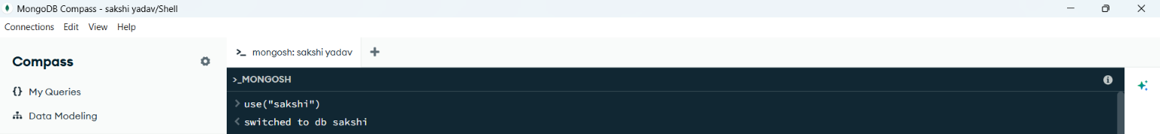

2. CREATE COLLECTION
MongoDB Query:
db. create Collection("dataset")
Explanation: Creates a collection named students.
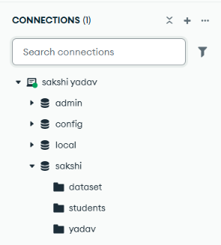
3. INSERT 50 STUDENTS
MongoDB Query:
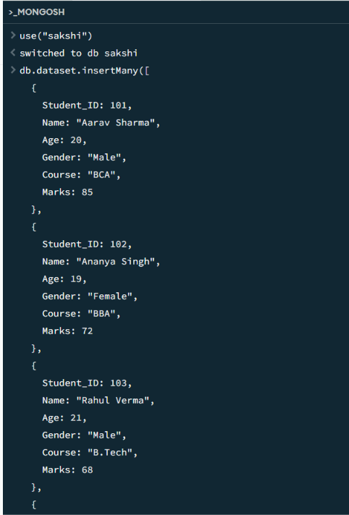
Explanation: Inserts multiple student documents into the collection.

4. DISPLAY ALL STUDENTS
MongoDB Query:
db.dataset.find()
Explanation: Retrieves documents from the students collection.
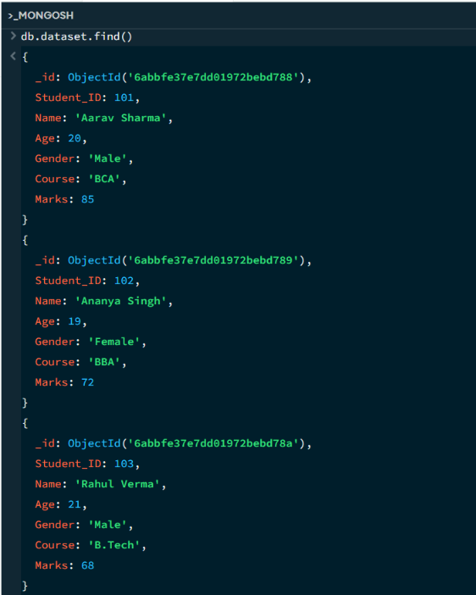
5. EQUAL TO — $eq
MongoDB Query:
db.dataset.find({Marks: {$eq: 86}})
Explanation: Finds students whose marks are exactly 86.
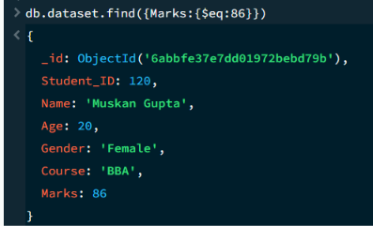
6. GREATER THAN — $gt
MongoDB Query:
db.dataset.find({Marks: {$gt: 85}})
Explanation: Finds students whose marks are greater than 85.
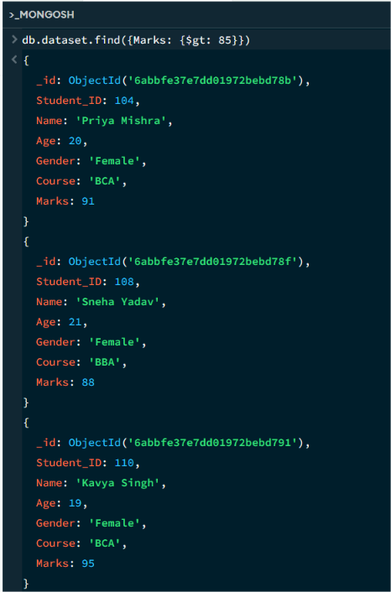

7. LESS THAN — $lt
MongoDB Query:
db.dataset.find({Marks:{$lt:60}})
Explanation: Finds students whose marks are less than 60.

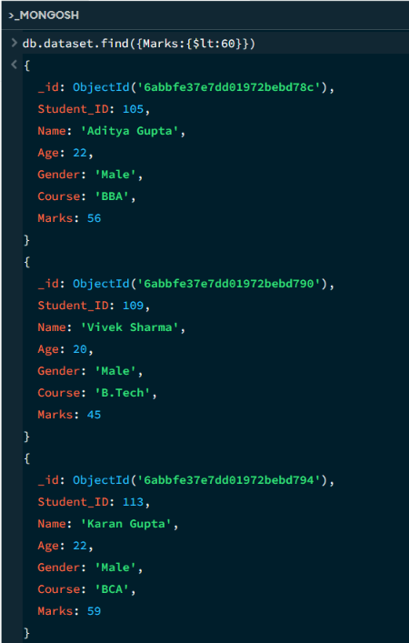
8. GREATER THAN OR EQUAL TO — $gte
MongoDB Query:
db.dataset.find({Marks:{$gte:90}})
Explanation: Finds students whose marks are 90 or above.

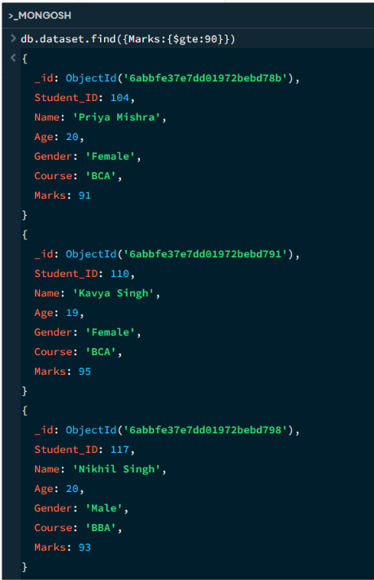

9. LESS THAN OR EQUAL TO — $lte
MongoDB Query:
db.dataset.find({Marks:{$lte:70}})
Explanation: Finds students whose marks are 70 or below.

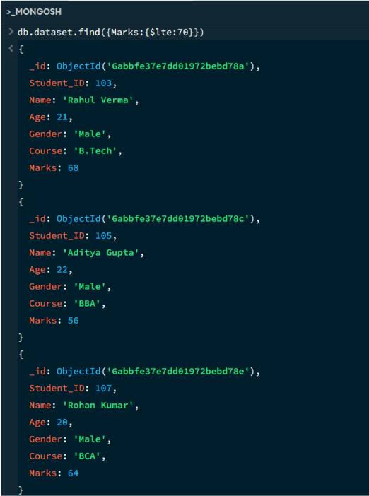

10. UPDATE OPERATION
MongoDB Query:
db.dataset.updateOne(
{Student_ID:113},
{$set:{Marks:95}}
)
Explanation: Updates the marks to 95 of the student with Student_ID:113.

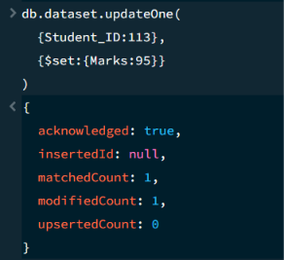

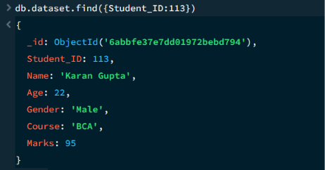
11. DELETE ONE OPERATION
MongoDB Query:
db.dataset.deleteOne({Student_ID:147})
Explanation: Deletes one document matching Student_ID:147.

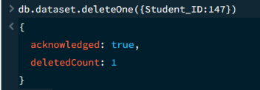

12. DELETE MANY OPERATION
MongoDB Query:
db.dataset.deleteMany({
marks: {$lt:60}
})
Explanation: Deletes all students having marks below 60.

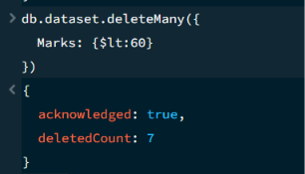

13. AND OPERATION — $and
MongoDB Query:
db.dataset.find({$and:[{Marks:{$gt:80}},{Age:19}]})
Explanation: Finds students satisfying both conditions.
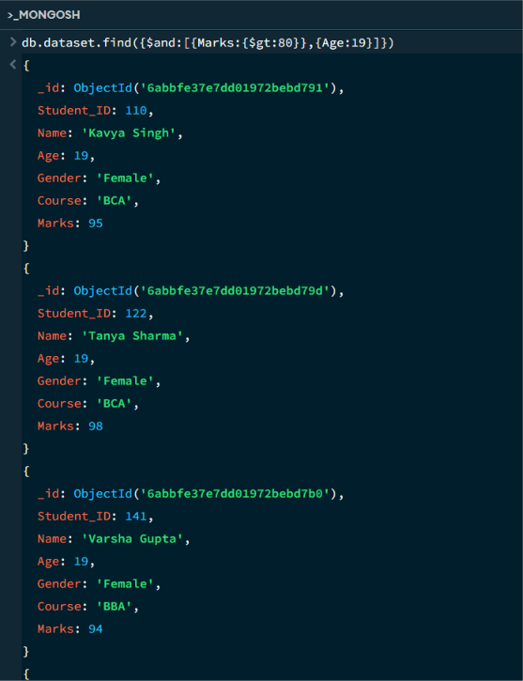

14. OR OPERATION — $or
MongoDB Query:
db.dataset.find({$or:[{Course:”BBA”},{Course:”BCA”}]})
Explanation: Finds students with Course “BBA” and “BCA”.
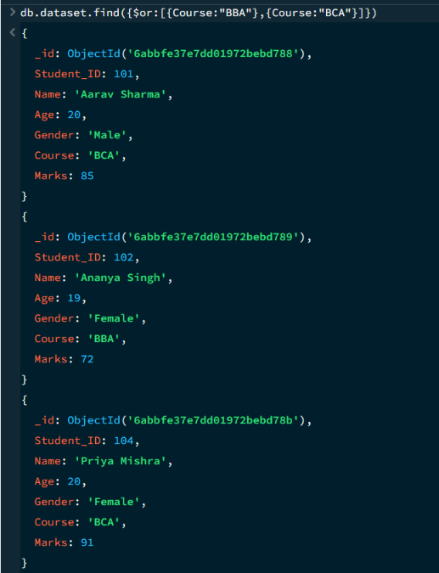

15. SORT OPERATION
A.MongoDB Query:
db.dataset.find().sort({Marks :1})
Explanation: Sorts students by marks from lowest to highest. Use 1 for ascending order.
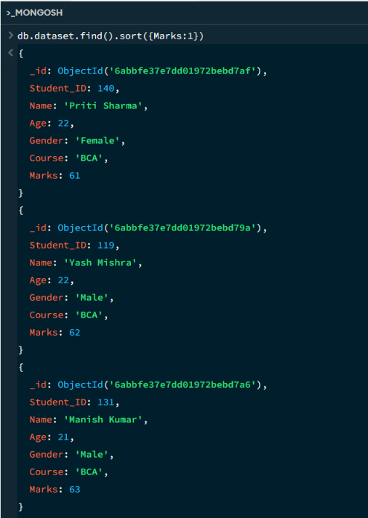

B. MongoDB Query:
db.dataset.find().sort({marks: -1})
Explanation: Sorts students by marks from highest to lowest. Use -1 for descending order.
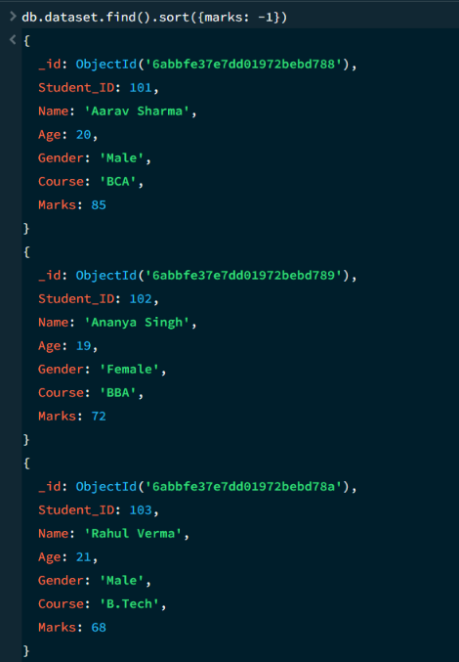
16. LIMIT OPERATION
MongoDB Query:
db.dataset.find().limit(5)
Explanation: Displays only the first five documents.

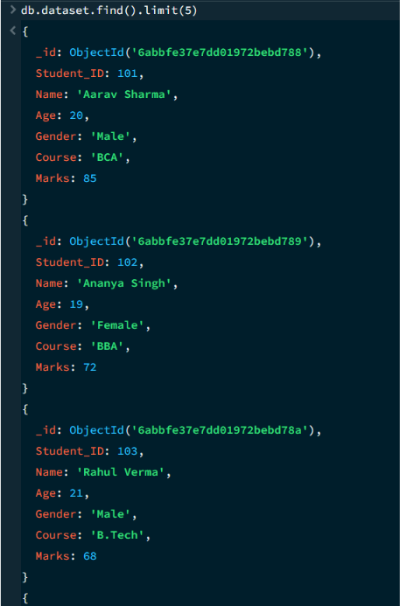

17. SEARCH BY CITY
MongoDB Query:
db.dataset.find({Age:22})
Explanation: Finds all students of Age 22.
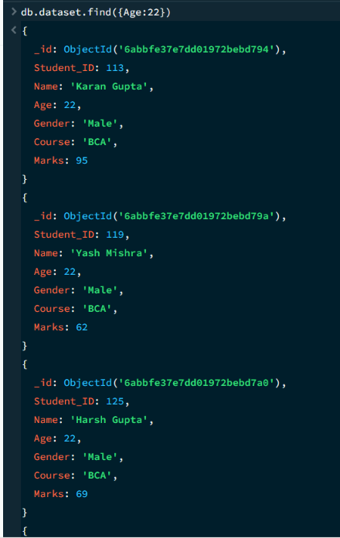

18. COUNT DOCUMENTS
MongoDB Query:
db.dataset.countDocuments()
Explanation: Counts documents currently present in the collection (performing after the delete function).
